Design an IoT-based aquarium tank

line 1: 1st Thinh Doan Vu
line 2: Faculty of Information Technology
line 3: Nha Trang University
line 4: Khanh Hoa, Viet Nam
line 5: thinhdv@ntu.edu.vn
line 1: 4th Thu Nguyen Thi Anh
line 2: Institution of Biotechnology and Environment
line 3: Nha Trang University
line 4: Khanh Hoa, Viet Nam
line 5: thunta@ntu.edu.vn
line 1: 2nd Hoang Nguyen Minh
line 2: Student of IT faculty
line 3: Nha Trang University
line 4: Khanh Hoa, Viet Nam
line 5: hoangnm.59ttql@ntu.edu.vn
line 1: 5th Cuong Le Thanh
line 2: Institution of Aquaculture
line 3: Nha Trang University
line 4: Khanh Hoa, Viet Nam
line 5: cuonglt@ntu.edu.vn
line 1: 3rd Cam Van Hong
line 2: Institution of Biotechnology and Environment
line 3: Nha Trang University
line 4: Khanh Hoa, Viet Nam
line 5: camvh@ntu.edu.vn

Abstract—Internet of Things (IoT) can be understood simply that all devices are connected to each other through the Internet. IoT have evolved due to the convergence of multiple technologies, real-time analytics, machine learning, commodity sensors, and embedded systems. There are numerous IoT applications in aquaculture such as collecting/updating data of water quality including temperature, dissolved oxygen, ammonia, nitrites, pH, temperature, salt, and carbonates. In this paper, the quality of water is monitored continuously with the help of 3-sensor (temperature, pH and dissolved oxygen) to ensure growth and survival of aquatic life. Each sensor is connected to Arduino device, the sensed data is transferred to master device before sending to Server. A Raspberry pi as a web server that allows real-time monitoring of water quality parameters via a website interface. E-mail alert sends to users when pond water parameters reach out of acceptable levels. In addition, the data is stored in a database (json format) and can be exported to Excel file.
Keywords-IoT, aquarium tank, Arduino, Rasperry pi, monitoring system.

Introduction
The hobby of fish keeping is loosely divided into three; brackish, freshwater, marine (Arvind & Shashikant, 2012). Freshwater is the foremost widespread hobby of keeping fish as, it is easy to handle with fish tank. In the recent years, mini aquarium tanks in various shapes and sizes, they need to be properly set up and maintained, or the fish will be destined to unpleasant and short life (Yi-Bing & Hung-Chun, 2019). Small aquarium tanks are not suitable for maintaining healthy fish (Dolan, 2015). The bigger the tank, the less impact a mistake will have on fish, and aquarium tanks of at least five gallons are suggested (Yi-Bing & Hung-Chun, 2019). In addition, effective fish tank management requires a realization of water quality. Water quality is determined by factors like Dissolved Oxygen (DO), temperature, turbidity, transparency, water colour, pH, carbon dioxide, alkalinity, hardness, conductivity, salinity, TDS, unionized ammonia, nitrate, nitrite, primary productivity, plankton population, BOD (Anita & Pooja, 2103). However, all those parameters need not to be monitored. Because there are some parameters whose imbalances cause the imbalances of other parameters and from the quantity of some parameters (Sajal, Rakibul, & Sumaiya, 2018).

Temperature
Temperature is defined as the degree of hotness or coldness in the body of a living organism either in water or on land (Lucinda & Martin, 1999). Temperature pronouncedly affects biological and chemical procedures. Rates of biological and chemical responses double for each 10°C increment in temperature in general (Sajal, Rakibul, & Sumaiya, 2018). Fish have poor resistance to sudden changes in temperature. Often, a quick change in temperature of as low as 5°C will stress or even slaughter fish. pH, DO, conductivity, salinity etc. are also directly dependent on temperature (Boyd, 1982). Higher temperature increased level of ammonia and decreased solubility of oxygen (Anita & Pooja, 2103). The levels of temperature as 30-35⁰C is tolerable to fish (Delincé, 1992)

pH
The pH is a ration of hydrogen ions concentration and designates whether the water is acidic or basic. The pH of natural waters is greatly influenced by the concentration of carbon dioxide (Boyd C. , 1979). pH between 7.0 to 8.5 is ideal for fish life because fish have an average blood pH of 7.4. Fishes can be died if pH of less than 4.0 or greater than 11 and become stressed in water with a pH ranging from 4.0 to 6.5 and 9.0 to 11.0 (Ekubo & Abowei, 2011). However, (Santhosh & Singh, 2007) supposed the suitable pH range for fish culture is between 6.7 and 9.5, below 6.7 or above 9.5 is stressful to the fishes. The ldeal pH level is between 7.5 and 8.5.

Dissolved oxygen
DO is one of the most important factors in aquaculture. DO, temperature and salinity (conductivity) are linearly related, due to high temperature and salinity increase, DO decrease. Oxygen depletion in water is cause of slow-growing of fish, reduced growth or death (Bhatnagar & Garg, 2000). An great aquatic environment, DO should higher or equal 80%. Most fish cannot live below 30% DO saturation (Svobodova, Richard, M., & Blanka, 1993).

THE AQUARIUM SENSORS AND HARDWARE
Rik Kretzinger designed an aquaponics garden based on Arduino microcontroller let you control your garden anywhere in the world (Kretzinger, 2021) through the implementation of Internet of Things (IoT). Marinov, Marin B. et al monitors environmental parameters with amperometric sensors and gas sensors (infrared) using the PIC18F87K22 microcontroller (Marinov, Ivan, Elitsa, & Georgi, 2016). Somansh Kumar designed an air quality monitoring system based on IoT using Rasbperry pi (Somansh & Ashish, 2017).
IoT technology use of sensors that provide remote, continuous, and real-time information of indicators related to environment parameters. Data acquired from the sensors system is uploaded to Arduino must be digital signal. This process called an analog-to-digital converter (ADC, A/D, or A-to-D) to converts an analog signal, such as a temperature, pH, DO value into a digital signal. At the end of IoT system, Raspberry Pi is a single board computer which serves as a webser. The values of the system parameters and information can be displayed on the web server continuously.

DS18B20 - Temperature sensor
Figure 1: Waterproofed DS18B20 Temperature sensor and Arduino Compatible module (Error: Reference source not found-a) from DFROBOT has 9 to 12bit resolution, ±0.5°C accuracy from -55°C ~ +125°C (-67°F ~ +257°F). This sensor is just required one pin data communication for multiple sensors at once. One Wire Library for Arduino is used to measure temperature with this sensor (DFROBOT, 2021).

SEN0169 - pH sensor
Analog pH Sensor for Arduino (SEN0161) from DFROBOT (Fig. 1-c) is used to measure pH of fish tank. The range of this sensor is 0-14 pH, operating in range 0-60⁰C. It has an accuracy of ±0.1 pH at a standard temperature of 25⁰C. A BNC connector is required to connect the sensor with Arduino (DFROBOT, 2021). The output of pH electrode is in millivolts, and the pH value of the relationship is shown in TABLE I

TABLE I. pH Electrode Characteristics
Voltage (mV) | pH value | Voltage (mV) | pH value
414.12 | 0.00 | -414.12 | 14.00
359.96 | 1.00 | -359.96 | 13.00
295.80 | 2.00 | -295.80 | 12.00
236.64 | 3.00 | -236.64 | 11.00
177.48 | 4.00 | -177.48 | 10.00
118.32 | 5.00 | -118.32 | 9.00
59.16 | 6.00 | -59.16 | 8.00
0.00 | 7.00 | 0.00 | 7.00

SEN0237 - Dissolved Oxygen sensor
SEB0237 module from DFROBOT is used to measure the dissolved oxygen in water, which in turn reflects the water quality (Error: Reference source not found). It is widely applied in many water quality applications, such as aquaculture, environmental monitoring and so on. This is Galvanic Probe type, detection range from 0 to 20 mg/L in 0~40⁰C (pressure range: 0~50 PSI) within 90 seconds (DFROBOT, 2021).

Arduino
As the sensors in this paper are specially designed for Arduino (Error: Reference source not found). Arduino Nano is a microcontroller board which is based on the ATmega328P. It has 8 analog input pins and 22 digital input/output pins (6 of which are PWM). Its operating voltage is 5V and recommended input voltage range is 7-12V. An Arduino IDE is required to program it. Arduino Nano can conduct data communication with computer via universal serial port (USB) (Arduino Nano, 2021).
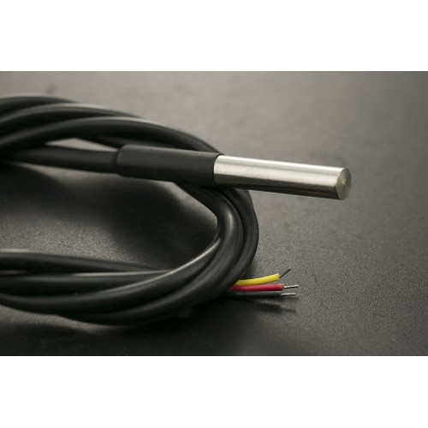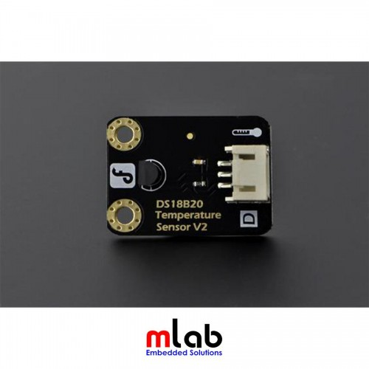  (a) | 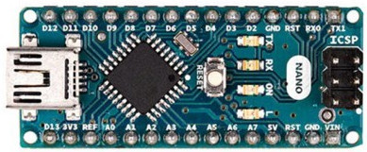  (b)
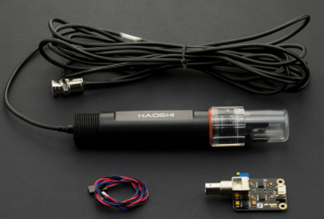  (c) | 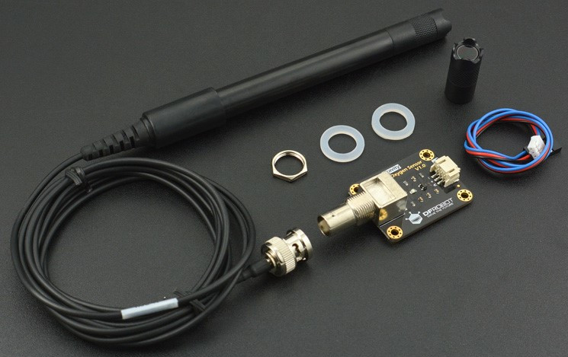  (d)
Fig. 1. Sensors and Arduino kit (Waterproofed DS18B20 Temperature sensor, and Arduino Compatible module (a); Analog pH meter Pro for Arduino (c); DO sensor and module for Arduino connection (d); Arduino Nano kit (b))

Raspberry Pi
The central processing unit of system is Raspberry Pi4 with 8GB RAM memory inside (Raspberry pi 4, 2021). Raspberry Pi is a single board computer, can support different operating systems such as Raspbian, Windows 10, Ubuntu etc. Ubuntu Desktop version 20.04 operating system is used for implementation of system. Raspberry pi can conduct serial data communication with Arduino via USB port.

system design AND SOFTWARE
Our sensor based water quality monitoring system measuring the pH, temperature, and DO is highly accurate, affordable, easy to use. Each sensor connected to digital pin of Arduino. A master Arduino collects all data from 3 others through SPI (Serial Peripheral Interface) protocol. Master device is interfaced with Raspberry pi via a USB cable to for sending the data to database (Fig. 2). Raspberry pi is connected to Internet with the help of Wi-Fi adapter. The data can be seen on the dashboard of website, this allow all users can be seen the status of fish tank any where only requirement is that device should be connected to Internet.
In addition, the system can also provide Email notification to users when these parameters are outside acceptable ranges (TABLE II). Users can thus take proper action to treat the fish tank after receiving alert messages from the system. The data can be exported to Excel file for analysis purpose.
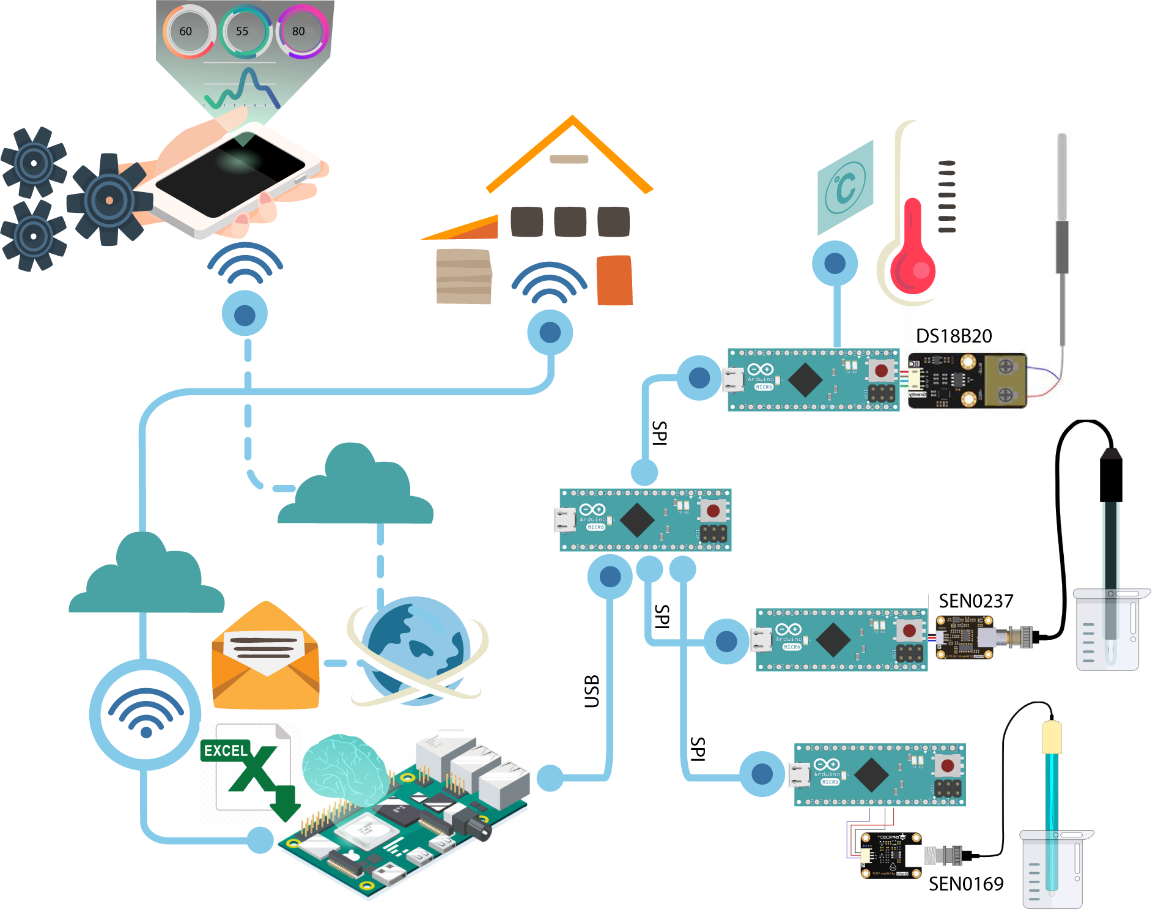
Fig. 2. Architecture of the IoT for mini aquarium system
TABLE II. RECOMMENDED WATER QUALITY PARAMETERS
Parameter | Unit | Acceptable levels | Desirable range
Temperature | ⁰C | 25-35 | 28-32
pH |  | 6.5-9.0 | 7.5-8.5
Dissolved Oxygen | mg/L | >3.0 | >3.5

Temperature reading
Temperature sensor requires a 4.7K Ohm resistor between the voltage and Signal pin when connect to Arduino directly. Multiple DS18B20s can exist on the same 1-Wire bus. This allows for placing temperature sensors in many different places. So, one wire library for Arduino is used to measure temperature with this. First step, open Arduino IDE and go to Manage Libraries, find and install OneWire library by Paul Stoffregen. Next, install the Dallas Temperature library by Miles Burton. Need to set number of byte address and select number of bit for analog to digital converting.

pH reading
pH sensor need to be calibrated by the standard solution to ensure accurate results before using every time. According to the manufacturer's recommendation, before the pH electrode can be used in different solutions, probe need to be washed in water using deionized water. In order to reading pH value, this is sample steps to use the pH Meter:
- Connect pH electrode to the BNC connector on the pH meter board，and the pH meter board is connected to ananlog port 0 on Arduino controller (see the blue LED on the board is on).
- Put the pH electrode into the standard solution whose pH value is 7.00 (or directly short the input of the BNC connector).
- Open the serial monitor of the Arduino IDE, and then read the pH value printed on it. Ensure that error does not exceed 0.3.
Identify applicable funding agency here. If none, delete this text box.
- Record the pH value printed, then compare that with 7.00. The difference should be changed in the "Offset" variable in the code.

Dissolved Oxygen reading
According to the manufacturer's documentation, 0.5 mol/L NaOH solution should be added into the membrane cap first as the filling solution.
- 0.5 mol/L NaOH solution should be added into the membrane cap first as the filling solution. If the cap is fully filled with NaOH solution, there will be too much solution overflowing when screwing the cap back to the probe. If the filling solution is too little, bubbles may be created inside the cap. In sum, the best way is to fill about 2/3 volume of the cap.
- The probe needs to be calibrated for accuracy if the probe has been used for the first time or some time.
- Connect the probe to BNC connector on the signal converter board. Connect the board to the analog input of Arduino main-board.
- Using sample code from manufacture’s for calibrating and reading value.

Master and Slave communication
SPI (Serial Peripheral Interface) is a protocol on four signal lines.
- A clock signal (SCLK) sent from the bus master to all slaves; all the SPI signals are synchronous to this clock signal (pin 13 on Master connected to pin 13 on Slave Arduino).
- A slave select signal (SSn) for each slave, used to select the slave the master communicates with (pin A1 to A3 on Master device used for selecting Salve device (pin 10): temperatue, pH, and DO modules, respectively).
- A data line from the master to the slaves, named Master Out-Slave In (MOSI, pin 12)
- A data line from the slaves to the master, named Master In-Slave Out (MISO, pin 11).
- Master init SPI transfer progress by SPI.setClockDivider function. Next, master send a byte to select Slave devices via SPI.transfer function. Slave selected device send data byte to Master on MISO pin. The master generates information onto the MOSI line while it samples the MISO line.

Webserver configuration
According to the manufacturer's documentation, 0.5 mol/L NaOH solution should be added into the membrane cap first as the filling solution.
- 0.5 mol/L NaOH solution should be added into the membrane cap first as the filling solution. If the cap is fully filled with NaOH solution, there will be too much solution overflowing when screwing the cap back to the probe. If the filling solution is too little, bubbles may be created inside the cap. In sum, the best way is to fill about 2/3 volume of the cap.

results
After the text edit has been completed, the paper is ready for the template. Duplicate the template file by using the Save As command, and use the naming convention prescribed by your conference for the name of your paper. In this newly created file, highlight all of the contents and import your prepared text file. You are now ready to style your paper; use the scroll down window on the left of the MS Word Formatting toolbar.

Authors and Affiliations
The template is designed for, but not limited to, six authors. A minimum of one author is required for all conference articles. Author names should be listed starting from left to right and then moving down to the next line. This is the author sequence that will be used in future citations and by indexing services. Names should not be listed in columns nor group by affiliation. Please keep your affiliations as succinct as possible (for example, do not differentiate among departments of the same organization).

For papers with more than six authors: Add author names horizontally, moving to a third row if needed for more than 8 authors.

For papers with less than six authors: To change the default, adjust the template as follows.

Selection: Highlight all author and affiliation lines.

Change number of columns: Select the Columns icon from the MS Word Standard toolbar and then select the correct number of columns from the selection palette.

Deletion: Delete the author and affiliation lines for the extra authors.

Identify the Headings
Headings, or heads, are organizational devices that guide the reader through your paper. There are two types: component heads and text heads.
Component heads identify the different components of your paper and are not topically subordinate to each other. Examples include Acknowledgments and References and, for these, the correct style to use is “Heading 5”. Use “figure caption” for your Figure captions, and “table head” for your table title. Run-in heads, such as “Abstract”, will require you to apply a style (in this case, italic) in addition to the style provided by the drop down menu to differentiate the head from the text.
Text heads organize the topics on a relational, hierarchical basis. For example, the paper title is the primary text head because all subsequent material relates and elaborates on this one topic. If there are two or more sub-topics, the next level head (uppercase Roman numerals) should be used and, conversely, if there are not at least two sub-topics, then no subheads should be introduced. Styles named “Heading 1”, “Heading 2”, “Heading 3”, and “Heading 4” are prescribed.

Figures and Tables

Positioning Figures and Tables: Place figures and tables at the top and bottom of columns. Avoid placing them in the middle of columns. Large figures and tables may span across both columns. Figure captions should be below the figures; table heads should appear above the tables. Insert figures and tables after they are cited in the text. Use the abbreviation “Fig. 1”, even at the beginning of a sentence.
- Table Type Styles
Table Head | Table Column Head
Table Head | Table column subhead | Subhead | Subhead
copy | More table copyª
- Sample of a Table footnote. (Table footnote)
- Example of a figure caption. (figure caption)
Figure Labels: Use 8 point Times New Roman for Figure labels. Use words rather than symbols or abbreviations when writing Figure axis labels to avoid confusing the reader. As an example, write the quantity “Magnetization”, or “Magnetization, M”, not just “M”. If including units in the label, present them within parentheses. Do not label axes only with units. In the example, write “Magnetization (A/m)” or “Magnetization {A[m(1)]}”, not just “A/m”. Do not label axes with a ratio of quantities and units. For example, write “Temperature (K)”, not “Temperature/K”.

Acknowledgment (Heading 5)
The preferred spelling of the word “acknowledgment” in America is without an “e” after the “g”. Avoid the stilted expression “one of us (R. B. G.) thanks ...”. Instead, try “R. B. G. thanks...”. Put sponsor acknowledgments in the unnumbered footnote on the first page.

References
The template will number citations consecutively within brackets [1]. The sentence punctuation follows the bracket [2]. Refer simply to the reference number, as in [3]—do not use “Ref. [3]” or “reference [3]” except at the beginning of a sentence: “Reference [3] was the first ...”
Number footnotes separately in superscripts. Place the actual footnote at the bottom of the column in which it was cited. Do not put footnotes in the abstract or reference list. Use letters for table footnotes.
Unless there are six authors or more give all authors’ names; do not use “et al.”. Papers that have not been published, even if they have been submitted for publication, should be cited as “unpublished” [4]. Papers that have been accepted for publication should be cited as “in press” [5]. Capitalize only the first word in a paper title, except for proper nouns and element symbols.
For papers published in translation journals, please give the English citation first, followed by the original foreign-language citation [6].

- G. Eason, B. Noble, and I. N. Sneddon, “On certain integrals of Lipschitz-Hankel type involving products of Bessel functions,” Phil. Trans. Roy. Soc. London, vol. A247, pp. 529–551, April 1955. (references)
- J. Clerk Maxwell, A Treatise on Electricity and Magnetism, 3rd ed., vol. 2. Oxford: Clarendon, 1892, pp.68–73.
- I. S. Jacobs and C. P. Bean, “Fine particles, thin films and exchange anisotropy,” in Magnetism, vol. III, G. T. Rado and H. Suhl, Eds. New York: Academic, 1963, pp. 271–350.
- K. Elissa, “Title of paper if known,” unpublished.
- R. Nicole, “Title of paper with only first word capitalized,” J. Name Stand. Abbrev., in press.
- Y. Yorozu, M. Hirano, K. Oka, and Y. Tagawa, “Electron spectroscopy studies on magneto-optical media and plastic substrate interface,” IEEE Transl. J. Magn. Japan, vol. 2, pp. 740–741, August 1987 [Digests 9th Annual Conf. Magnetics Japan, p. 301, 1982].
- M. Young, The Technical Writer’s Handbook. Mill Valley, CA: University Science, 1989.

References

[1] | D. S. Arvind and S. S. Shashikant, "Smart Electronic System for Pond Management in Fresh Water Aquaculture," in 2012 IEEE Symposium on Industrial Electronics and Applications (ISIEA2012), Bandung, Indonesia, 2012.
[2] | L. Yi-Bing and T. Hung-Chun, "FishTalk: An IoT-Based Mini Aquarium System," IEEE Access, vol. 7, pp. 35457 - 35490, 2019.
  [1] | D. S. Arvind and S. S. Shashikant, "Smart Electronic System for Pond Management in Fresh Water Aquaculture," in 2012 IEEE Symposium on Industrial Electronics and Applications (ISIEA2012), Bandung, Indonesia, 2012.
  [2] | L. Yi-Bing and T. Hung-Chun, "FishTalk: An IoT-Based Mini Aquarium System," IEEE Access, vol. 7, pp. 35457 - 35490, 2019.
  [3] | A. Dolan, "The effects of aquarium size and temperature on color vibrancy, size, and physical activity in bettasplendens," in Tech. Rep., Maryville College, Maryville, TN, USA, 2015.  Anita, B., & Pooja, D. (2103). Water quality guidelines for the management of pond fish culture. International Journal of Environmental Sciences, 3(6), 1980-1993.  Arvind, D. S., & Shashikant, S. S. (2012). Smart Electronic System for Pond Management in Fresh Water Aquaculture. 2012 IEEE Symposium on Industrial Electronics and Applications (ISIEA2012), (pp. 173-175). Bandung, Indonesia.  Dolan, A. (2015). The effects of aquarium size and temperature on color vibrancy, size, and physical activity in bettasplendens. Tech. Rep. Maryville College, Maryville, TN, USA.  Lucinda, C., & Martin, N. (1999). Oxford English Mini - Dictionary Oxford. New York: University Press Inc.  Sajal, S., Rakibul, H. R., & Sumaiya, K. (2018). IoT Based Automated Fish Farm Aquaculture Monitoring System. 2nd Int. Conf. on Innovations in Science, Engineering and Technology (ICISET) (p. 202). Chittagong, Bangladesh: IEEE.  Yi-Bing, L., & Hung-Chun, T. (2019). FishTalk: An IoT-Based Mini Aquarium System. IEEE Access, 7, 35457 - 35490.

IEEE conference templates contain guidance text for composing and formatting conference papers. Please ensure that all template text is removed from your conference paper prior to submission to the conference. Failure to remove template text from your paper may result in your paper not being published.

We suggest that you use a text box to insert a graphic (which is ideally a 300 dpi TIFF or EPS file, with all fonts embedded) because, in an MSW document, this method is somewhat more stable than directly inserting a picture.
To have non-visible rules on your frame, use the MSWord “Format” pull-down menu, select Text Box > Colors and Lines to choose No Fill and No Line.

